Statistic

Collection of methods, principles to collect data

--analyze info, make decisions

Descriptive Statistics-Gather, Sort, Summarize data from Samples.

Inferential Statistics-Uses descriptive statistics(Data) to estimate population paratmter.

Raw Data

Eg. Observations/measurements/labels before analysis

|  |  |  |  |
| --- | --- | --- | --- |
| Raw | Handedness | Height(cm) | Courses |
| 1 | R | 155 | 3 |
| 2 | R | 185 | 4 |
| 3 | R | 177 | 5 |

Variable-any characteristic that varies

Observational unit- the people or things under study

Sample Size-how many observational units

Data-all the data

Big Idea

Use data from a sample (some subset) to answer questions about the population – whole set of obs. Units

-usually sample is small

In a census, sample=population

*census—systematically acquiring and recording info about the members of given population

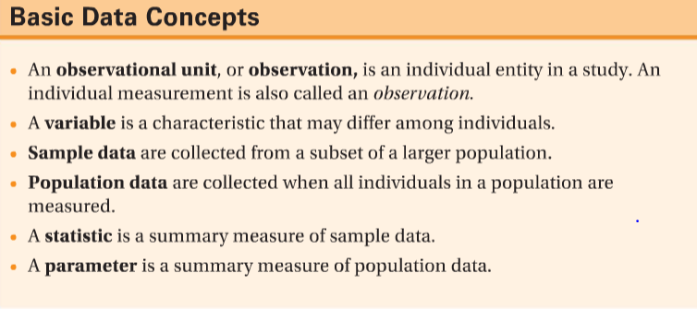

Statistics—numbers summarizing sampled data

Parameters—numbers summarizing population data

Categorical- category name or label

Summarize with count or percent in each category

Subtype: ordinal has an order

Quantitative—count or measurement

Lots of summaries

Subtype: continuous if valves can be anything in a range

INCKUDE UNIT (ex. cm/kg/m….)

**Think parameter as the whole and sample is a portion of it(statistics)

A categorical variable

What % of DC student are left-handed?

A quantitative variable

What is the average course load for DC student?

Two quantitative variable

Are international student more likely to graduate “on time”?

Two quantitative variables

How does incoming HS average affect/interact with number of courses?

Explanatory variable – HS average

Response variable – number of courses

One categorial & quantitative

Is height affected by gender?

